Andrew Caughey

**“Win-Win” Cooperation: Parsing the Jargon of China’s Newly Assertive Foreign Policy**

“Win-win” cooperation has become a ubiquitous phrase in Party discussions on foreign policy, but is the term worth taking seriously? Though “win-win” appears in several critical Party documents including 2019’s Defense White Paper, the phrase sometimes seems tacked on to add fuzzy good-will or “positive energy” – but not any specific meaning. While it’s true that “win-win” is sometimes just an appended empty vector, it would be a mistake to dismiss the phrase’s importance out of hand. Instead, tracking usage of win-win in People’s Daily headlines overtime helps us better understand where, how, why, and with whom the PRC is hoping to cultivate win-win cooperation. Those answers, in turn, suggest how the Party itself might perceive and address foreign policy challenges in Xi’s New Era.

To explore and contextualize Beijing’s win-win rhetoric, I text-scraped a database of People’s Daily articles from 1946 to 2020 that contained win-win (共赢) in the headline. I gathered 880 headlines, publication dates, and over 500 topic keywords to better understand the topic of each article. This method only reflects the broad outlines of the conversation, since body text is not included, and tells us little about how policies are implemented. Still, with that in mind, this tool can help us critically asses Beijing’s messaging strategy and we can better draw inferences about the kind of policies and partnerships they are pursuing. People’s Daily articles, especially headlines, are carefully edited to harmonize Party messages and reflect the contours of attitudes, perceptions, and beliefs that shape Beijing’s policy.[1] Combined with careful qualitative research, we can start to separate win-win’s signal from the noise.

As the Party transitions from hiding-and-biding to a more activist role in international affairs, win-win rhetoric is most often used in the People’s Daily articles as part of a two-pronged messaging strategy designed to shape public views about Beijing’s more assertive foreign policy. First, highlighting the pursuit of “win-win” policies assuages popular concerns that a rising China and the US might stumble into a Thucydides-trap conflict. At the same time, however, this rhetoric grounds China's new foreign policy initiatives in sovereignty-based language that deliberately contrasts with perceived U.S. unilateralism abroad and its alleged “Cold War mentality”. Still, despite the term’s centrality in the 2019 Defense White Paper, in state media win-win rhetoric has been focused primarily on economic development over security cooperation – with special emphasis on the Belt and Road Initiative in developing countries overseas. This messaging strategy might sound quite appealing to countries hoping to deepen their partnerships with China, but today there is some indication that win-win rhetoric may have outlived its usefulness in nearby countries as concerns about China's relative power grow. As a whole, state media’s usage of win-win suggests the BRI is the Party’s primary vehicle for win-win economic cooperation abroad, but that a concrete vision for international security cooperation, especially with Indo-Pacific neighbors, may still lag far behind.

In the last two decades, “win-win” has become a common phrase in state media and Party discourse, but there’s been relatively little academic exploration of what the term might mean. This is understandable. Semi-authoritative Party writing on the concept is often unfocused, spanning nearly every policy area with scant specifics.[2] Further, Party discourse is jargon-laden and terms come in and out of vogue all the time in what Barmé calls “the stilted diction of bureaucratese….scientific and academic jargon…mix[ing] argot and vernacular with the wooden language of Communist Party discourse.”[3] In other words, it’s difficult to read, and some terms seem to have little meaning in practice. This is sometimes true of “win-win” itself.

Still, the proliferation of “win-win” in high-level officialdom invites more scholarly attention. In Xi’s 2017 Davos speech to the World Economic Forum, the term appears at least once nearly every other page and underpins his call for a Community of Common Destiny (人类命运共同体). It receives its own section header in China’s National Defense in the New Era 2019 White Paper, and is used nearly ten times in the Lead Group for the Belt and Road Initiative’s 2017 White Paper.[4] Figure one shows People’s Daily headlines containing the term (共赢) have steadily risen for twenty years, and notably jumped when Xi Jinping became General Secretary, and also when he announced the BRI. Until 2000, win-win did not appear in a single headline but has since lead over 800 articles.

**Figure 1**

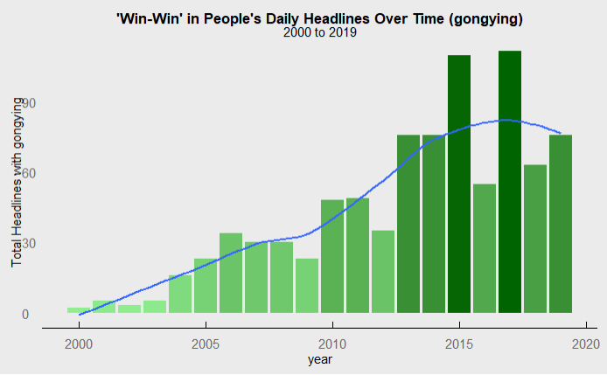

The term’s roots extend back to the 1954 “Five Principles of Peaceful Coexistence” and the Non-Aligned Movement, but today the term has new meaning. [5] While not as authoritative a source as the People’s Daily, the China Institute of International Studies argues “win-win cooperation is a theoretical system which transcends the set pattern of ‘hiding our capacities and biding our time while making some achievements.” Here, win-win rhetoric is described as the basis for a transitional propaganda and policy strategy for Xi’s bolder, more active foreign policy that was incompatible with the previous era’s reserve and quietude abroad. If that’s the case, then understanding what kind of win-win policies are being pursued should give us a better understanding of China’s evolving foreign policy.

Propaganda often highlights win-win policies and proposals to allay fears that China’s rise means inevitable conflict with the United States, but the term itself is as much about drawing a contrast with the U.S. as pursuing cooperation. In People’s Daily, along with the BRI, win-win is most commonly used in discussions about the US-China relationship (see Figure 2 and Figure 4). CIIS heralds win-win as a “new type of major power relations with the US as the key…to overcoming various kinds of predicaments and traps.” This model, though, is light on specifics. At the same time, win-win is meant to deliberately contrast with perceived US unilateralism and offer an alternative to would-be comprehensive partner countries. CIIS writes, “it is completely different from hegemonism, imperialism…new-interventionism…Cold War mentality and alliance forming,” and in the words of the State Council of Information Office “the proposal…opposes…power politics and hegemonism.”[6] In this way, win-win rhetoric tries to ground itself in respect for national sovereignty, which is core to China’s own claims about its rightful status as a rising power player to reshape Western rules in international relations and organizations.[7] Win-win rhetoric has been used at the UN, for example, to package sovereignty-based resolutions which would free Beijing’s hand by tying human rights to local development (not universal values) as a “win-win” investment in “humanity’s shared density.”[8] In short, though the data and case study both show win-win rhetoric centers around the Sino-U.S. relationship, this is not just an invitation for U.S. cooperation, but is also a messaging tool for Beijing to draw out contrasts in pursuit of international influence, partnerships, and policy-setting that often run counter to U.S. interests.

While Figure 1 shows that the term win-win entered the Party discourse in state media during the mid-2000’s, the term has since become deeply tied to the Belt and Road Initiative. Besides general synonyms for win-win (双赢) and cooperation (合作), BRI is far-and-away the most often discussed topic when win-win is included in People’s Daily headlines.[9] Pursing “win-win” outcomes was clearly part of foreign policy and messaging before BRI, but it has since become the primary vehicle for these designs. It should be said that many BRI projects may truly be “win-wins” for partner countries and Beijing: China’s excess labor and material capacity flow out to developing countries who need public goods and infrastructure.[10] While there have been concerns about debt-trap diplomacy,[11] especially in the wake of China’s 99 year lease on a Sri Lankan port, Beijing has to-date worked with partners to restructure their debt before seizing assets.[12] Some partners, though, worry that BRI projects do not make use of local labor and may stoke tensions with local communities, and, in the end, are more a win for Beijing than the host nation.[13]

Alongside BRI, what kind of “win-win” policies does state media promote? In Party-State white papers and speeches, there’s been much discussion of pursuing “win-win” security policies. 2019’s Defense White Paper is a clear example: “committed to the principle of win-win cooperation, China’s armed forces will fulfill their international responsibilities and…provide more public security goods to the international community.”[14] The paper offered some specifics and focused on military exchanges, disaster preparation, and UN Peacekeeping. In state media, though, pursuing win-win security policies has not been the main focus of the discussion. Together, Figures 2 and 3 suggest economic policies, not security, constitute the bulk of win-win rhetoric. BRI-adjacent terms like “construction” and “economy” dominate the most common article topic keywords, but “peace” comes in the middle of the pack. Similarly, of all 880 articles, security appears in only about 10 headlines, and BRI language is, again, more common. Further, potential forums for win-win security cooperation, including the Shanghai Cooperation Organization highlighted in the Defense White Paper, are not mentioned in any win-win headlines. This is an imperfect measure, but gives some indication that, for-now, the focus of win-win rhetoric remains squarely on economic and cultural policies.

**Figure 2**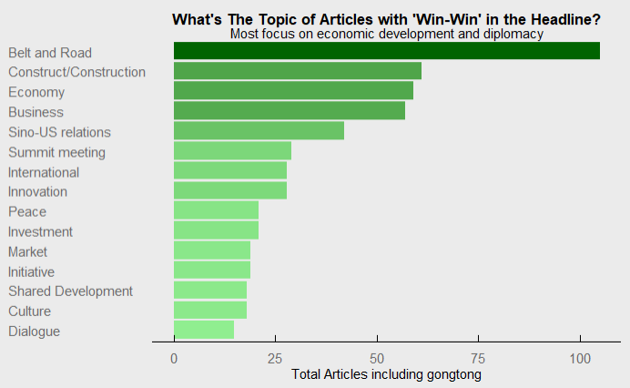

**Figure 3**

But who is Beijing partnering with, and where are these policies being highlighted? In Figure 4, besides the U.S., Sino-African relations have by far the most mentions, while Latin America also ranks highly. Notably, this analysis did not include individual African or Latin American countries in this category, but instead only articles tagged with terms like “Africa Cooperation” or “Sino-Africa Relations”. If individual countries were included, both would likely be much larger. Otherwise, “win-win” rhetoric is largely directed toward regional powers and established US allies. This makes sense – we have seen how the term is designed to allay concerns about China’s rise stoking conflict. Still, qualitative case study could better flesh out our understanding here, and text analysis only gives us a first-pass assessment. Finally, some individual BRI countries are frequently mentioned (Kazakhstan), and many BRI countries are the focus of one or two articles. Ideally, these measures would also be normalized to account for the total number of articles published on relations with these countries, but that was not possible for this short project.[15]

**Figure 4**

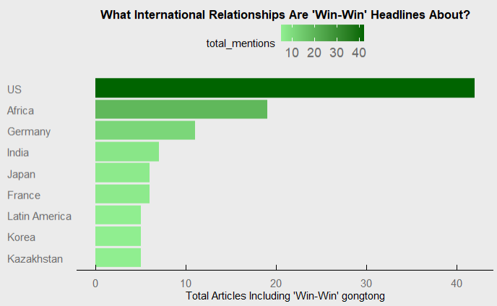

It’s worth noting, here, that “win-win” rhetoric is often applied to far-off developing regions, and not those closer to China’s own borders. Southeast Asia, Central Asia, and ASEAN, for example, do not seem to be as frequently discussed as Africa and Latin America in the win-win frame. This methodology alone cannot explain why that’s the case, but theory can help guide possible explanations. Womack argues that win-win rhetoric is no longer as appealing to China’s neighbors as it once was. As the power differential grows larger and larger, asymmetries and economic uncertainties make it difficult for China to credibly commit to even win-win policies and projects, making “the fear of risk more vivid than the prospect of gain.”[16] This may be especially true for China’s neighbors, whose security is more directly impacted by China’s rise. In contrasts, win-win projects may be more credible in more distant African and Latin American countries, where improving ties with China and building out comprehensive strategic partnerships may not significantly change, and likely will not harm, security and economic relationships.

**Figure 5**

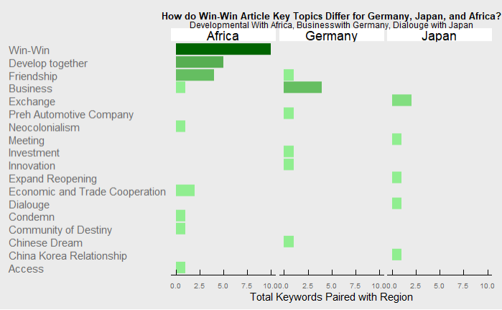

This is not only a difference in quantity, but in kind, as Figure 5 makes clear. Articles about win-win cooperation in developing African countries are much more likely to discuss economic cooperation, trade, and development. Here, language like “develop together” emphasizes China’s own status as a developing country, as it often does in Latin American win-win rhetoric.[17] This focus on economic policies may be somewhat surprising, given that the People’s Liberation Army in 2017 opened their first overseas Naval Support Station in Djibouti. Still, in general state media has tried to down-play its military applications, so it is understandable this approach would not pick up on this important security development.[18] Indeed, this reflects the constraints of Beijing’s transitional foreign policy: though newly assertive and eager to provide public security goods, the state still carefully messages to assuage concerns about provoking future military conflicts, especially with the U.S. Highlighting economic win-wins in Africa may help do just that. In Germany, a developed U.S. ally, the pursuit of “win-win” policies seems laser focused on cooperation with businesses, often explicitly mentioning companies like Preh by name. When the term is applied to rivals like Japan, though, the term seems to be just dressing on vague calls for cooperation and dialogue: there aren’t many specifics here, and beyond exchange, it’s not clear what kind of “win-win” policies are being pursed. This is when the term is at its fuzziest, most abstract, and empty. In contrast, “win-win” rhetoric seems to be more specific and focused in far-off countries and developing nations.

While some of the win-win rhetoric is positive puffery, there's grounds to take some of it seriously, and its worth considering what kinds of win-win cooperation China will seek out and where. As part of its strategy to develop comprehensive partnerships, China is likely to continue pursue and highlight win-win economic development in peripheral developing countries through the BRI, especially with African nations. For now, though there does not yet seem to be much focus on fleshing out win-win security cooperation in Party rhetoric. This could be an opening for would-be competitors like the United States and the European Union; perhaps economic competition with the BRI isn't realistic in the short run, but stepped up security cooperation might be. Further, the relative lack of discussion of win-win cooperation with Southeast Asian countries, accompanied by the drop in mentions last year, might illustrate a coming evolution in China's transitional foreign policy. This could be another opportunity for the U.S. and partner countries to highlight the provision of public goods and security in Indo-Pacific public diplomacy messaging.

**Appendix**

**Figure i**

I also explored usage of 双赢 over-time, another synonym for “win-win” in Chinese. However, ultimately this analysis focused on 共赢 because 双赢 appears to be a less popular term, and 共赢 may be preferred in party discourse. Still, a follow-up project could study both terms together.

**Figure ii**

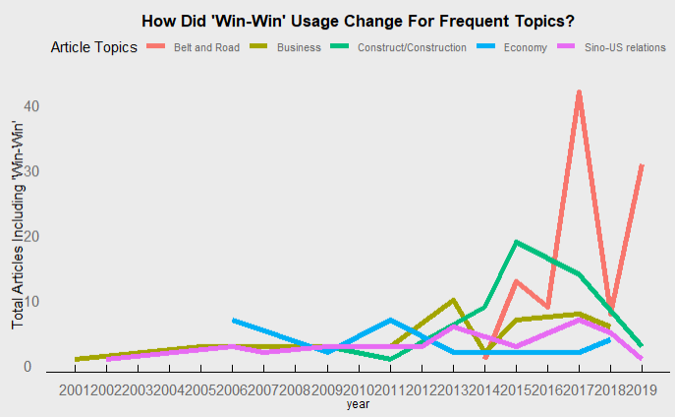

This chart shows how the most often discussed win-win topics have changed over time. Two interesting patterns emerge. First, win-win rhetoric regarding the United States has been relatively unchanged over time across U.S. administrations and the Hu to Xi transition. Further, BRI win-win rhetoric has fluctuated significantly in the past three years. In the year of the first BRI Forum, BRI win-win rhetoric hit is peak. Amidst concerns about debt-trap diplomacy and unfair lending, usage of the term “win-win” seems to have been dialed back but increased again in the same year as the second BRI Forum, which aimed to address these concerns. A fuller analysis would explore these trends by the week or month to see if these events really coincided, but that was beyond the scope of this project.

1. Guoguang Wu. “The Politics of Editorial Formulation in the People’s Daily.” *The China Quarterly,* No. 137 (March 1994).; Wen-Hsuan Tsai, Peng-Hsiang Kao. “Secret Codes of Political Propaganda: The Unknown System of Writing Teams.” *The China Quarterly,* 214*.* June 2013.
2. Chen Xulong. “Win-Win Cooperation: Formation, Development and Characteristics.” China Institute of International Studies. November 17, 2017.
3. Barmé, Geremie R. “New China Newspeak”. *China Heritage Quarterly.* http://chinaheritage.net/journal/on-ne-china-newspeak/
4. “China and the World in the New Era.” The State Council Information Office of the People’s Republic of China. September 2019. ; “China’s National Defense in the New Era.” The State Council Information Office of the People’s Republic of China. September 2019. ; Xi Jinping, “Jointly Shoulder Responsibility of Our Times, Promote Global Growth” (Speech, Davos, January 17 2017).
5. Womack, Brantly. “Beyond Win-Win: Rethinking China’s International Relationships in an Era of Economic Uncertainty.” *International Affairs* No. 89*.* 2013. 
6. Chen Xulong. “Win-Win Cooperation: Formation, Development and Characteristics.” China Institute of International Studies. November 17, 2017.; “China and the World in the New Era.” The State Council Information Office of the People’s Republic of China. September 2019.
7. Xi Jinping, “Jointly Shoulder Responsibility of Our Times, Promote Global Growth” (Speech, Davos, January 17 2017).
8. Piccone, Ted. “China’s Long Game on Human Rights at the United Nations.” *Foreign Policy at Brookings.* September, 2018.
9. See Appendix Figure i for flagging usage of 双赢 over time, and discussion of why this analysis focuses on 共赢instead.
10. Alves, Ana-Cristina. “China’s ‘win-win’ cooperation: Unpacking the Impact of Infrastructure-for-Resource Deals in Africa.” *South Africa Journal of International Affairs,* Vol. 20, No. 2. 2013.; Chakrabarty, Malancha. “Ethiopia – China Relations: A Classic Win-Win Situation?” *World Review of Political Economy,* Vo. 7, No. 2 (Summer 2016).
11. See figure ii in the appendix for more discussion of how win-win rhetoric in BRI-focused articles may have adjusted as these concerns mounted in 2018.
12. Kratz, Feng, and Wright. “New Data on the ‘Debt Trap’ Question.” Rhodium Group. April 29, 2019.
13. Bernal-Meza, Raúl. “China and Latin America Relations: The Win-Win Rhetoric.” *Journal of China and International Relations.* 2016; Rolland, Nadège. *China’s Eurasian Century? Political and Strategic Implications of the Belt and Road Initiative.* Ch 3.
14. “China’s National Defense in the New Era.” The State Council Information Office of the People’s Republic of China. September 2019.
15. This would be done by constructing a simple ratio of a country or region’s articles that include win-win in the headline over the total number of articles in PD written about that country over the same period of time. However, the API made text scraping all of that a very difficult process, but this is one place where this research could be improved.
16. Womack, Brantly. “Beyond Win-Win: Rethinking China’s International Relationships in an Era of Economic Uncertainty.” *International Affairs* No. 89*.* 2013. 
17. Bernal-Meza, Raúl. “China and Latin America Relations: The Win-Win Rhetoric.” *Journal of China and International Relations.* 2016
18. Xinhua wrote “the Djibouti base has nothing to do with an arms race or military expansion, and China has no intention of turning the logistics center into a military foothold,” though the base is heavily fortified. Headley, Tyler. “China’s Djibouti Base: A One Year Update.” *The Diplomat*. December 04. 2018.